**Unveiling Marketing Insights: Analysing Spending Behaviour and Identifying Opportunities for Growth**

1. **INTRODUCTION**
   1. **Overview**

The goal of the field of market insights is to learn about and analyse the market. Data on the market, consumers and Competitors must be gathered, analysed and interpreted by individuals in this role. Their main objective is to give important important information and viewpoints to company decision-makers, helping them to make wise decisions and create plans.

A Market Insights expert must be able to break down data and draw out relevant information. It’s essential to have the ability to differentiate between hidden patterns and a broader context.

To create an effective marketing campaign, it’s essential to know your product or service, target audience and your goals. A market insight is the discovery of a relevant, actionable and previously unrealized reality about a target market as the result of deep, subjective data analysis.

* 1. **Purpose**

Marketing insights benefit both parties by meeting your target audience’s needs and wants while also profiting. This is especially true when marketing a previously unused or unknown innovation. In other words, the best market insights help those selling the invention and the companies.

A market insights is the discovery of a relevant, actionable and previously unrealized reality about a target market as the result of deep, subjective data analysis. Marketing analysis is important because it give you the ability to uncover opportunities within a market; to know what you customers think of your products; improves your communication and messaging platforms with your customers.

1. **PROBLEM DEFINITION & DESIGN THINKING**
   1. **Empathy Map**

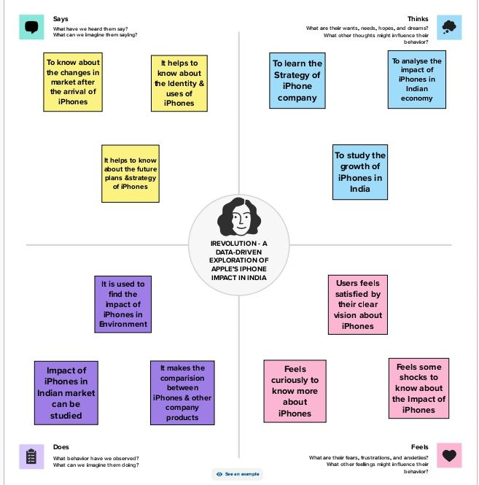

**2.2. Ideation & Brainstorming Map**

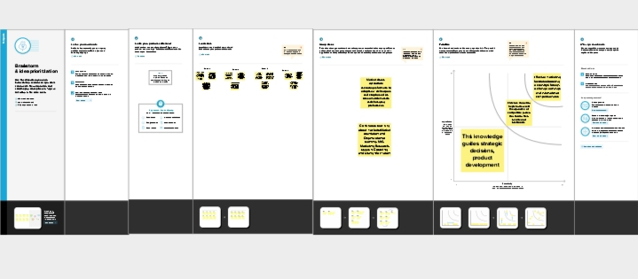

**RESULT**

**Dashboard**

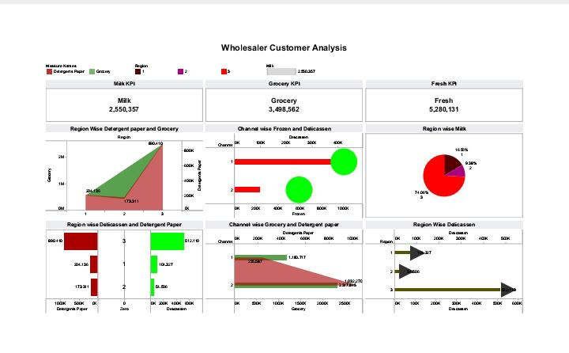

**Story**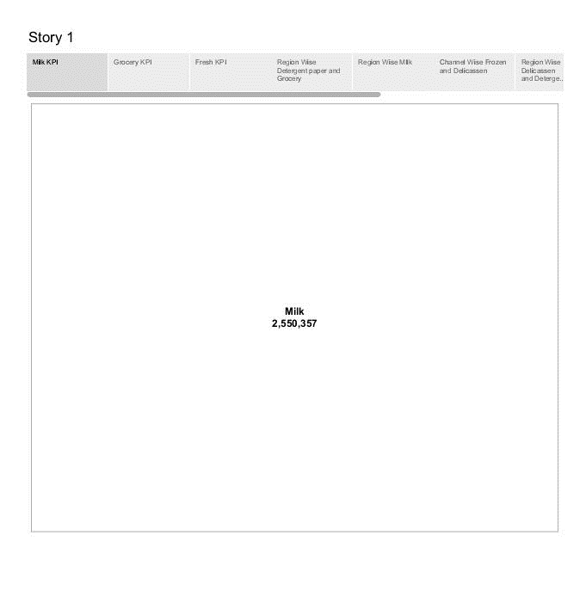

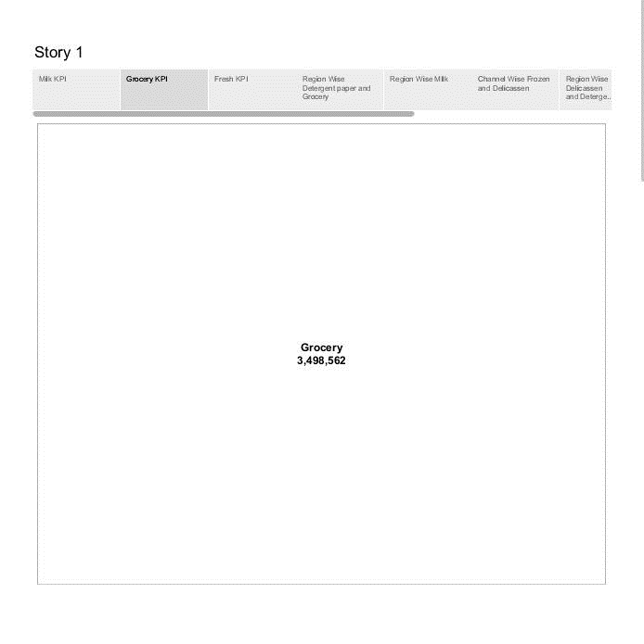

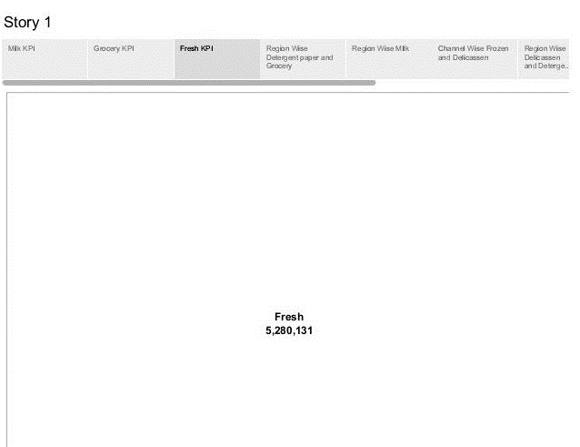

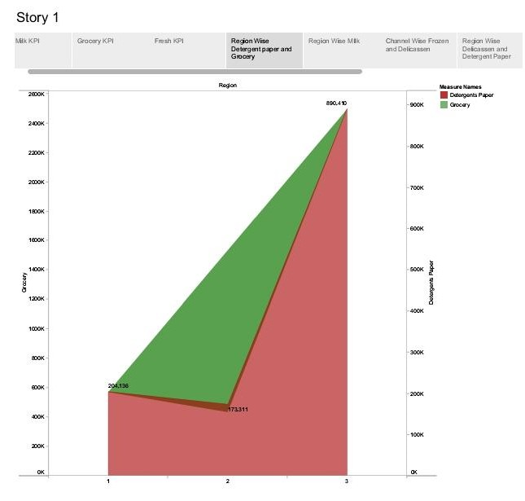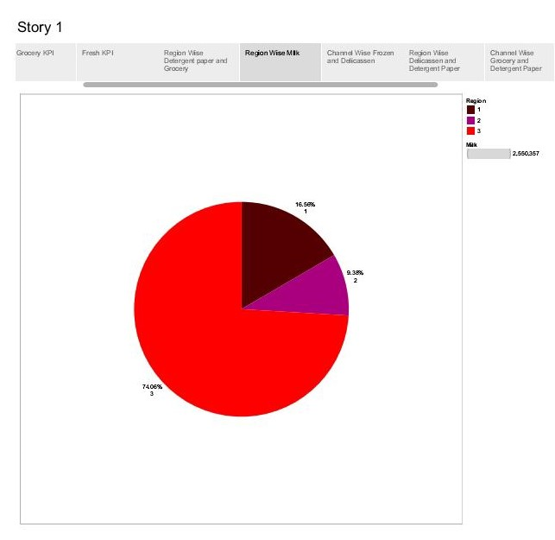

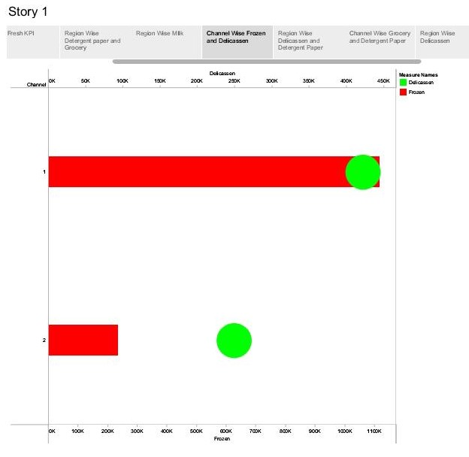

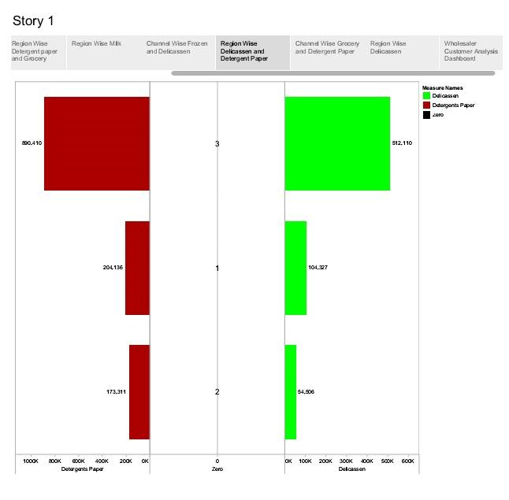

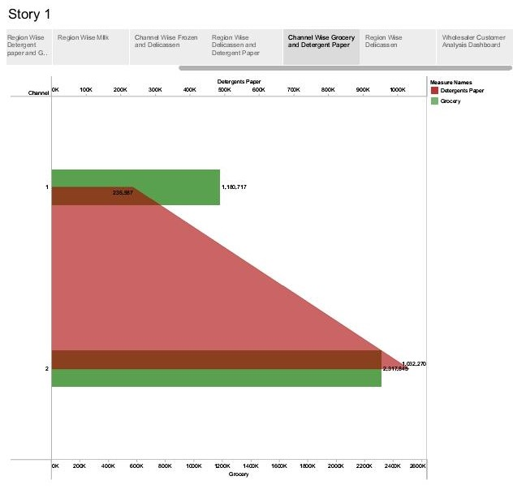

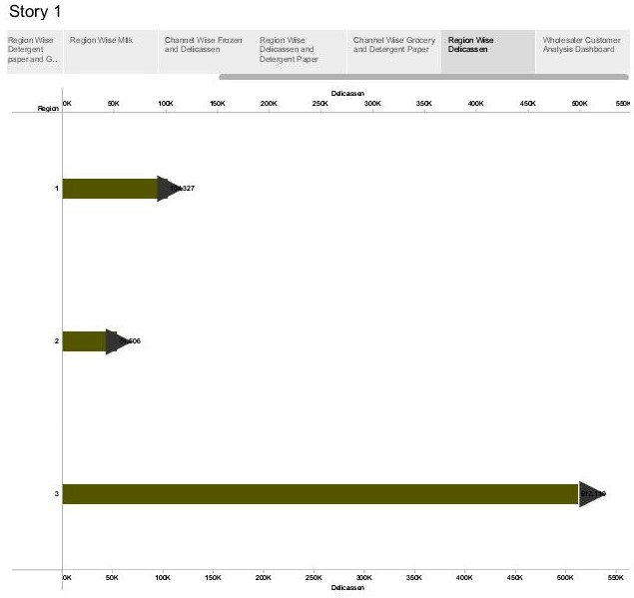

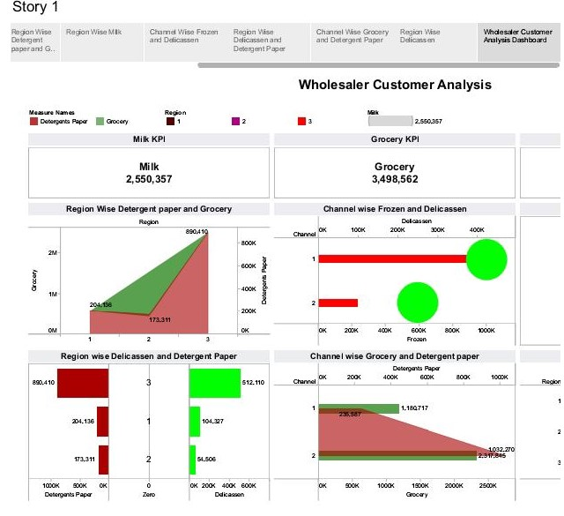

# **ADVANTAGES**

* Promotes Your Business to a Target Audience
* Helps You Understand Your Customers.
* Identify Opportunities for Growth.
* Reduce Risks by Testing Concepts.
* The main advantages of primary market research or up-to-date information, customized data, and up-to-date information.
* The benefits of a market economy include increased efficiency, production, and innovation.

**DISADVANTAGES**

* Costs of Marketing.
* Time and Effort May Not Yield a Return.
* One of the most common issues in marketing analytics is a surplus of incoming data.
* The main disadvantages of primary market research are costs, time, potential risk of biased results.
* The disadvantages of a market economy include monopolies, no government intervention, poor working conditions, and unemployment.
* The disadvantages of market economy are intense competition, poor working conditions, environmental degradation, and economic disparities.

**APPLICATIONS**

* Marketing is applied when communicating the value of a company’s product to potential customers.
* Market insights help businesses make informed decisions about

Market positioning, product development and expansion strategies.

* Tailoring marketing campaigns based on market insights can improve targeting and messaging, leading to more effective advertising.
* Segmenting the market based on insights helps companies target specific customer groups with personalized products and services.
* Market dynamics aids in selecting the right entry strategy, whether

through partnerships, acquisitions, or organic growth.

**CONCLUSION**

Problem Definition & Design Thinking is done by creating Empathy Map and Brainstorming Map. Data visualization is done by creating graphical representations. The goal of Data is to make complex Data sets more assesible, Intuitive and easier to interpret. Dashboard for this project is created which is cruicial to ensure that the information is easily understandable and finally story is done which is the way of presenting data and analysis in a narrative format. The main goal of storyboard is making the information more engaging and easier to understand. By build this project we can understood the Unveiling Market Insights.

**FUTURE SCOPE**

In future, Advantages are generated and the Disadvantages are rectified for Customers Satisfaction and the Data visualization is created with many data sets, so the visualizations gives Interesting Graphs.